CONTENTS

Page
- INTRODUCTION 1-17
  - Introduction to automobile industry
  - Objective of the study
  - Need of the study
  - Limitations of the study
  - Tools and techniques

- REVIEW OF LITERATURE 18-23
- COMPANY PROFILE 24-30
- UNDERTAKING KEY DELIVARIES 31-44
- DATA ANALYSIS AND INTERPRETATION 45-59
- FINDINGS AND SUGGESTIONS 60-62
- ANNEXURE 63-68
- BIBLIOGRAPHY 69-70
- HYUNDAI CAR MODELS 71-74

CHAPTER-1
INTRODUCTION

Automobile Industry History
Sales behavior towards customer is our main motto of the project. The business will depend on the sales man behavior customer. This company was started in the year 1769, a French engineer by the name of Nicolas J. Cugnot invented the first automobile to run on roads. This automobile, in fact, was a self-powered, three-wheeled, military tractor that made the use of a steam engine. The range of the automobile, however, was very brief and at the most, it could only run at a stretch for fifteen minutes. In addition, these automobiles were not fit for the roads as the steam engines made them very heavy and large, and required ample starting time. Oliver Evans was the first to design a steam engine driven automobile in the U.S. The success of this company is due to the sales man behavior towards customer.
A Scotsman, Robert Anderson, was the first to invent an electric carriage between 1832 and 1839. However, Thomas Davenport of the U.S.A. and Scotsman Robert Davidson were amongst the first to invent more applicable automobiles, making use of non-rechargeable electric batteries in 1842. Development of roads made travelling comfortable and as a result, the short ranged, electric battery driven automobiles were no more the best option for travelling over longer distances.
The Automobile Industry finally came of age with Henry Ford in 1914 for the bulk production of cars. This lead to the development of the industry and it first begun in the assembly lines of his car factory. The several methods adopted by Ford, made the new invention (that is, the car) popular amongst the rich as well as the masses.
According the History of Automobile Industry US, dominated the automobile markets around the globe with no notable competitors. However, after the end of the Second World War in 1945, the Automobile Industry of other technologically advanced nations such as Japan and certain European nations gained momentum and within a very short period, beginning in the early 1980s, the U.S Automobile Industry was flooded with foreign automobile companies, especially those of Japan and Germany.

The current trends of the Global Automobile Industry reveal that in the developed countries the Automobile Industries are stagnating as a result of the drooping car markets, whereas the Automobile Industry in the developing nations, such as, India and Brazil, have been consistently registering higher growth rates every passing year for their flourishing domestic automobile markets.
Those who are interested in gathering more information about the Automobile Industry, may browse through the following links

- World Automobile Industry
- Automobile Industry Trends
- India Automobile Market
- India Automobile Industry

The World Automobile Industry is turned to the developing markets.
With the developed markets almost saturated, the World Automobile Industry is now focused on the developing markets of South America and Asia, and Eastern Europe with special emphasis on BRIC (Brazil, Russia, India, and China).
As per the reports of the International Organization of Motor Vehicle Manufacturers or OICA(the association of the companies involved in World Automobile Industry), for the fiscal end in 2006, the automobile manufacturers in the U.S. have been overtaken by those in Japan, in terms of the total volume of automobile units manufactured worldwide.

However, the struggling General Motors of the U.S. still remain the worldwide leaders of the World Automobile Industry, ahead of the rapidly growing Toyota Motor Corporation of Japan, by a substantial margin.

Measures to be adopted by global leaders of the World Automobile Industry.
Several significant economic measures are being considered by the major players of the World Automobile Industry in order to make a smooth entry into the markets of the developing countries, and to make a name for themselves. The effective measures include :
- Reducing the selling prices of the automobiles manufactured in their factories
- Improving the levels of after-sales services to keep customers satisfied
- Opening manufacturing factories in the developing nations, to reduce effective costs of production as well as saving shipping charges, and enhancing prompt delivery of automobile units.
Automobile Industry Trends

In keeping with the Automobile Industry Trends, the leading automobile manufacturers are turning to the Asian markets that appear set to grow immensely over the next decade. The automobile markets in the U.S., Europe and the Japan have almost matured as a result of saturation and appear set to decline through the next decade. In contrast, the automobile markets spread over the entire Asian continent (with the exception of Japan), are constantly increasing in size and will be the destination for most of the globally leading automobile manufacturers.
The Automobile Industry Trends reveal that the emerging markets of the developing nations of Asia especially China, and India are backed by their huge population growth rate, to add to the growing national economy of these two nations.
The rapid growth of the national economy of the BRIC countries (including Brazil, Russia, India, and China) have enabled a growing section of the population of these countries to purchase automobiles. Global surveys conducted recently reveal that within the next ten years, these emerging automobile markets will account for nearly a whooping 90 percent of the global automobile sales growth. As a result of this, leading Automobile manufacturers of the world are setting up factories in the emerging markets, in order to serve the potential consumers better as well as reduce manufacturing and shipping costs. In addition, these arrangements are enabling the leading global automobile manufacturers to compete with the local automobile manufacturers, that were flourishing in the absence of quality competition.
The prosperity of the national economy is reflected in the rising per capita income of the developing nations. Therefore, increasing Gross Domestic Product and per capita income have raised the purchasing ability of the population that constitutes these emerging markets
As a growing percentage of the population in the developed nations age rapidly, in comparison to the rest of the world, these aging numbers necessitate automobiles to fit the physiological change of the world population.

The Emerging India Automobile Market.
The India Automobile Market is a promising industrial sector that is growing immensely every passing year. The passenger cars are referred to, through the use of the word "automobile." The whooping growth experienced by the Indian Automobile Market in the last financial year itself, that is the financial year end in February, 20016, was very close to a 18 percent over the previous fiscal. This statistical fact is a glittering example of the potential of the growing Automobile Industry in India.
As per the survey conducted by the Society of Indian Automobile Manufacturers, the total number of automobiles manufactured by the Automobile Industry in India, throughout the financial year 2015-16, was very close to the 15.5 lakh (1.5 million) margin. The huge of number of automobiles manufactured by the Automobile Industry in India was an enormous growth upon the number of automobiles manufactured during the previous fiscal, that ended in 2016.
The total number of cars that were exported from India were very close to the 2.0 lakh (2.0 hundred thousand) margin, an encouraging sign for the Automobile Industry in India. The export of cars manufactured in India comprised nearly 13 percent of the total number of cars manufactured domestically by the Automobile Industry in India.
The India Automobile Market looks set to prosper, largely due to the growing market for automobiles that is developing in India. In the financial year that ended in February, 2004, the Indian automobile markets were the fastest growing in the world, with the registered growth rate touching nearly 20 percent.
The Automobile Industry in India mainly comprises of the small car section, which enjoys nearly a 2/3rd market share of the entire market for automobiles in India. In this respect, the Indian markets are the largest in the world for small cars, behind Japan.
The Indian passenger car market which ranks amongst the largest in the world, is poised to become even more larger and enter the top five passenger car markets in the world in the next decade.

India Automobile Industry

Following India's growing openness, the arrival of new and existing models, easy availability of finance at relatively low rate of interest and price discounts offered by the dealers and manufacturers all have stirred the demand for vehicles and a strong growth of the Indian automobile industry.

The data obtained from ministry of commerce and industry, shows high growth obtained since 2011- 12 in automobile production continuing in the first three quarters of the 2014-05. Annual growth was 16.0 per cent in April-December, 2014; the growth rate in 2013-04 was 15.1 per cent The automobile industry grew at a compound annual growth rate (CAGR) of 22 per cent between 1992 and 1997.
With investment exceeding Rs. 50,000 crore, the turnover of the automobile industry exceeded Rs. 59,518 crore in 2002-03. Including turnover of the auto-component sector, the automotive industry's turnover, which was above Rs. 84,000 crore in 2002-03, is estimated to have exceeded Rs.1,00,000 crore ( USD 22. 74 billion) in 2003-04.
Automobile Dealers Network in India
In terms of Car dealer networks and authorized service stations, Maruti leads the pack with Dealer networks and workshops across the country. The other leading automobile manufactures are also trying to cope up and are opening their service stations and dealer workshops in all the metros and major cities of the country. Dealers offer varying kind of discount of finances who in tern pass it on to the customers in the form of reduced interest rates.
Major Manufacturers in Automobile Industry
- Maruti Udyog Ltd.
- General Motors India
- Ford India Ltd.
- Eicher Motors
- Bajaj Auto
- Daewoo Motors India
- Hero Motors
- Hindustan Motors
- Hyundai Motor India Ltd.
- Royal Enfield Motors
- Telco
- TVS Motors
- DC Designs
- Swaraj Mazda Ltd
Government has liberalized the norms for foreign investment and import of technology and that appears to have benefited the automobile sector. The production of total vehicles increased from 4.2 million in 1998- 99 to 7.3 million in 2003-04. It is likely that the production of such vehicles will exceed 10 million in the next couple of years.
The industry has adopted the global standards and this was manifested in the increasing exports of the sector. After a temporary slump during 1998- 99 and 1999-00, such exports registered robust growth rates of well over 50 per cent in 2002-03 and 2003-04 each to exceed two and- a-half times the export figure for 2001-02.

Automobile Export Numbers

Category | 2018-19 | 2020-21 (Apr-Dec)
Passenger Car | 25468 | 121478
Multi Utility Vehicles | 2654 | 3892
Commercial Vehicles | 10108 | 19931
Two Wheelers | 100002 | 256765
Three Wheelers | 21138 | 51535
Percentage Growth | -16.6 | 32.8

THE KEY FACTORS BEHIND THIS UPSWING
Sales incentives is increased due to there behavior towards customer, introduction of new models as well as variants coupled with easy availability of low cost finance with comfortable repayment options continued to drive demand and sales of automobiles during the first two quarters of the current year. The risk of an increase in the interest rates, the impact of delayed monsoons on rural demand, and increase in the costs of inputs such as steel are the key concerns for the players in the industry.
As the players continue to introduce new models and variants, the competition may intensify further. The ability of the players to contain costs and focus on exports will be critical for the performance of their respective companies.
The auto component sector has also posted significant growth of 20 per cent in 2003-04, to achieve a sales turnover of Rs.30,640 crore (US$ 6.7 billion). Further, there is a potential for higher growth due to outsourcing activities by global automobiles giants. Today, this sector has emerged as another sunrise sector.

EVEN GROWTH
Sales incentives is increased due to there behavior towards customer .Opposing the belief that the growth in mobile industry has catered only to the top income-stratum of society, Growth of exports of 32.8 % in the first three quarters of 2004-05, the fastest growth in volumes has come from commercial vehicles as against passenger cars.
Between 1998-99 and 2003-04, output of commercial vehicles has grown 2.8 times compared to the 2.2 times increase in passenger cars. Furthermore, two-wheeler output continues to dominate the volume statistics of the sector. In 2003-04, for every passenger car turned out by the sector, there were 7 two-wheelers produced. In the two wheeler segment, there is a greater preference for motorcycles followed by scooters, with both production and domestic sales of motorcycles increasing at faster rates than for scooters in the current and previous years. However, mopeds have registered low or negative growth. Export growth rates have been high both for motorcycles and scooters.

EXECUTIVE SUMMARY
Lakshmi Hyundai is into automobile business since last 11 years. It has a total turnover of Rs. 55 Crores with total strength of around 225 personnel employed in various capacities.
Customer satisfaction is a concept that more and more companies are putting at the heart of their strategy, but for this to be successful, they’re needs to be clarity about what customer satisfaction means and what needs to happen to drive improvement. Sales incentives is increased due to there behavior towards customer

NEED FOR STUDY
Increasing competition, ever growing market, easy availability of the finances and increasing population of young executives, with huge disposable incomes, over the past few years has substantially increased the sales in the automobile industry. Also, the competition among the dealers of the products has increased with each trying to maximize their customer base. This makes it imperative for the dealers to provide the best of the services and exceed the customer expectations to achieve customer delight and loyalty.
The study tries to understand the key service parameters and reflect upon the dysfunctional areas, thus providing the dealer with an insight into the level of customer satisfaction and changing trends of the customer expectations.

OBJECTIVE OF THE STUDY

To study and understand the key service parameters using Customer Satisfaction and reflect upon the low performing areas:

- To study about the customer satisfaction on the services provided by the dealers.
- Sales incentives is increased due to there behavior towards customer.
- To study the opinion of the customers regarding the availability and cost of spare parts.
- To study the opinion of the owners of cars regarding its features like mileage, price etc.
- To study the effect of advertisement on the customers to promote the product.
- To study the customer satisfaction with usage of their cars.
- To study the information resources that the customer using before purchasing the car.
SCOPE OF THE PROJECT
- The research measures the experiences of customers.
- Defines and analyses the experiences based on key deliverables.
- Gains insights into Customer expectations.
- Sales incentives is increased due to there behavior towards customer
Limitations:
The study is restricted in scope of owing to the following limitations:

- Due to constraint of time only city of Hyderabad is selected and so it cannot claim to be a comprehensive study of the population.
- The sample size is restricted to 100 respondents.

RESEARCH METHODOLOGY
Preliminary stage of study- a pilot survey, personal interview of sales consultants, potential customers and existing customer numbering 20 was conducted to arrive at key deliverables which would ensure customer satisfaction. The research tool (questionnaire) was designed by inducing the various queries, based on the key deliverables, which would reflect the customer satisfaction.
The research was based on a study of a sample, sized 100, using simple random sample selected from the existing database of Lakshmi Hyundai. The research included collection of data from the primary sources using the research tool (questionnaire). Final stage was to analyze, interpret and draw conclusions from the data collected
Date Sources:
Primary Data:
The data is collected directly from each and every customer.
Pilot Survey
A pilot survey was conducted to understand the factors, which would positively influence the customer. Personal Interviews totaling 20 were conducted for the sales team, potential customers and the existing customers of Lakshmi Hyundai. The factors scoring high in the interviews were considered to be the key deliverables.
Survey Research:
The research was done to learn about people’s preferences and satisfaction of the Lakshmi Hyundai customer. Sales incentives is increased due to there behavior towards customer

Research Tool:
Questionnaire (primary tool- attachment 1)
Interview through questionnaire method was employed for the research purpose. The questionnaires were individually administered to each customer to ensure minimum scope for faulty data entry and error of understanding. This method also gave the interviewer the scope of entering into a dialogue and understanding the customer’s perception better.
The questionnaire tried to capture the responses of the customers mainly on the key deliverables, derived from the pilot survey conducted, and a few questions have been included to gauge the level of satisfaction and to gain insight into customer expectations.

Unstructured interview
The interview complemented the primary research tool and helped delver into details of responses provided by the customers. This not only validated the responses of the customers but also helped the interviewer understand the expectations of the customers.
Sampling Unit: In this study the sampling unit used is the existing customer base of Lakshmi Hyundai. Selection is made from the list of Customers during the last one year.
Sampling Size: Sample size was chosen to be 100.
Sampling Procedure: Simple Random Sampling.
In simple random sampling, each member of the target population has the same chance of being selected for participation in the study. For a sample to truly be a simple random sample we need to develop a list or sampling frame that includes almost all of the population, then from this we randomly pull names from the sampling frame using some kind of random method such as a random number table or a random number generator. Finally, numbers are assigned to all members of the population and pull the names of those members whose numbers are pulled from the table or generator.
The biggest advantage to a simple random sample is that we get a pretty good unbiased sample fairly easily. The biggest downside is that we may not get all elements of the population that are of interest.

CHAPTER-2
REVIEW OF LITERATURE

CUSTOMER SATISFACTION
Concept Identification-
As organizations become increasingly customer focused and driven by demand, the need to gain customer loyalty and retain their loyalty is critical. Customer satisfaction is the most effective way to achieve customer loyalty. Sales incentives is increased due to there behavior towards customer. Customer satisfaction and customer loyalty share many similar traits. Customer value is the customer’s perception of the ratio of benefits to what he or she gives to obtain those benefits. The customer Value Triad is a framework used to understand what it is that customers want. The framework consists of three parts: (1) perceived product quality, (2) value-based pricing, and (3) perceived service quality.
Customers are satisfied, when value meets or exceeds expectations. If their expectations of value are not met, there is no chance of satisfying them. Figuring out what the customers want, however, is a difficult and complex process. To be able to create and deliver customer value is important to understand its components. On the most basic level, value from a customer’s perspective is the ratio of benefits to the risks being taken while buying the product.
CUSTOMER SATISFACTION
AN INSIGHT
According to Harold E Edmondson “ Customer Satisfaction” seems to appear in print more frequently than any other catch phrase used to describe a new found magic for industrial success. Before we proceed in to the study of the dynamics of Customer Satisfaction it is important to know about, who a customer is and what satisfaction really means. Sales incentives is increased due to there behavior towards customer.

Who really is a Customer?
The question of defining who your customers are seems fairly easy particularly if you have segmented your market properly and understand who you are trying to satisfy. However subtlety that frequently goes undetected by many firms is that is that customer set can be divided into two parts, the apparent customer and the user. The apparent customer is the person or group of people who decide what product to buy and basically have control over the purse strings. The user is a person or group who physically uses the product or is the direct recipient of a service.
What does satisfaction really mean?
As in defining customer above, defining satisfaction also appears simple. However as with customer there is a subtlety that needs addressing. Satisfaction by most definitions simply means meeting the customer’s requirement.
Customer satisfaction is a concept that more and more companies are putting at the heart of their strategy, but for this to be successful they’re needs to be clarity about, what customer satisfaction means and what needs to happen to drive improvement. Without this, there is a risk that customer satisfaction becomes little more than a good intention, with confused objectives failing to address the real issues for customers, one helpful way to look at the problem is to rephrase the objectives: set the sights on helping the customers meet their goals.
Customer satisfaction can be defined in many different ways. Finding the right way for a company depends on understanding your customer and on having a clear vision of the role that customer satisfaction is to play in the strategy. For example, a focus on customer satisfaction can work alongside existing segmentations to support revenue generation from high value customers or it can be a company-wide objective rooted in the brand values. For the former, it may be sufficient to focus on improving customer service, but for the latter a broader definition of customer satisfaction is necessary, closer akin to corporate reputation.
Whatever the strategy for customer satisfaction, it must at least include getting the basics right. Failing to achieve this can destroy the reputation as well as losing valuable customers. Every customer, regardless of their economic worth to the business, has the power to influence – positively or negatively – a company’s reputation. Once the objectives for the customer satisfaction strategy are defined there are a number of steps we can take to make sure the focus on customer satisfaction is effective.

Building a company around Customer Satisfaction -
With the increase in customer’s demands and competition it has become a lot more important to base the entire company on customer service. When doing this one must first realize that every member of an organization plays an active role in customer service. This includes both external customers and internal customers within a company.
Customer focused organizations focus both on customer satisfaction and profit. Achieving customer satisfaction generates the profit. In these organizations top management has frequent contacts with external customers. The top management uses consultative, participative, and supportive management styles to get through to the customer. The staff focuses all of its attention on satisfying the customer’s needs. However, the management’s job is to provide the staff with support necessary to achieve these goals. The other department and staff in the organization that do not have direct contact with the external customers deal exclusively with internal customer satisfaction.

The Influence of the salesperson in Customer Satisfaction-
In an article titled, “The influence of salesperson selling behavior on customer satisfaction with products,” Brent G.Goff and James S. Boles examine the effects of non-product related construct on customer satisfaction with major retail purchases such as automobiles. The article states that salesperson’s selling orientation- customer orientation (SOCO) will affect not only consumer satisfaction with the salesperson and dealer, but also indirectly, satisfaction with the product or manufacturer.
In the perspectives of both the retailer and the manufacturer, customer satisfaction represents an important issue because it relates to several desirable outcomes. Customer satisfaction leads to future purchases, and repeated purchases of the same product from the same source. In other words, it helps a firm retain its present customers and build loyalty. By helping a buyer obtain product information and providing guidelines about what should be expected during the buying process and use of a product, a salesperson may influence customer expectations concerning the product. Thereby this may reduce the likelihood of dissatisfaction (Grewal and Sharma, 1991). A successful salesperson tailors to the needs of each individual customer. By being customer-oriented, a salesperson is likely to identify with needs of the customer, enabling the salesperson to match his or her presentation to those requirements of the customer.

Internal Marketing – how it affects Customer Satisfaction –
Successful companies make every effort to ensure satisfaction to their customer by focusing all organizational efforts of the company on providing superior customer service. By doing this these companies hope to retain their existing customers and attract new ones. Only angle of customer satisfaction commonly overlooked is the internal aspect.
The internal customer or employee plays a vital role in achieving customer satisfaction and loyalty. Some firm’s do not understand that the treatment of internal customers becomes the external customers’ perception of the company. A firm’s employees or other departments within the organization make up its internal customers. Their job performance affects the firm’s ability to deliver superior product and customer service (Boone and Kurtz, 1999). When a firm’s employees are happy at work, their overall attitude and performance towards the customer enhances tremendously. Internal marketing helps members or employees of an organization understand and fulfill their roles in implementing its marketing strategy. Internal marketing not only keeps employees happy, it also shows them how their actions affect the firm’s ability to achieve customer satisfaction.
Customer Satisfaction as part of Service Profit Chain:
A Harvard Business Review article outlines the internal process required to drive growth and increase profitability. The article describes the ways in which service quality contributes to success, outlining the steps in the “Service-profit chain”:

Profitability / Growth
Customer Loyalty

Customer Satisfaction
Value
Employee Productivity
Employee Loyalty
Internal Quality

Leadership

CHAPTER-3
COMPANY PROFILE

PROFILE OF HYUNDAI
“Hyundai” a name to be reckoned in the World Automobile industry is Korea’s number one automaker. Hyundai has established an enviable record for growth both in quantitative and qualitative terms transforming itself from a domestically oriented manufacture into a global player and leading contributor to Korea’s economic and industrial development. Hyundai Motor Company is steadily accelerating to achieve the status of world-class automobile company.
In December 1967, Hyundai Motor Company (HMC) was born out of the Hyundai Business group, the nation’s largest conglomerate with the purpose of entering the automobile industry to meet the growing domestic demand for cars. Since then, HMC has played a major role in providing transportation to further Korea’s economics growth and prosperity.
Entry of Hyundai Motor Company in the Indian Market.
Hyundai established its presence in India by opening a subsidiary called “Hyundai Motor India Limited” with a total investment of US$ 614 Millions. The Hyundai project is the largest to be made by an MNC in the automobile sector. The plant near Chennai, in the state of Tamil Nadu is the largest manufacturing plant of Hyundai motors outside Korea and contains nearly all facilities necessary for a self sufficient manufacturing and production site for developing cars. This assembly plant not only boasts it sown assembly facilities but also a R&D center, a performance experimenting and testing center, and a driving testing ground. As such, the India plant represents a family-type combined automobile assembly facility, capable of all production processes, research and development, testing of products, marketing for sales and provision of after sale service in India.
In 1997, Hyundai Motor India limited launched “Santro” the best small car at its worldwide debut in New Delhi. Santro is basically a face lifted version of the “Atos”. Santro was introduced in three different models having varying features. Santro was a runaway success in the India market and became famous as the Tall Boy car. It topped the volumes year after year in its segment.

Products rolling out of Hyundai Motor India Ltd.
The products that come out of the Hyundai Motor’s desk are
- Santro Zing
- Accent
- i20
- Sonata
- i10 (kappa 1.2)
- Getz
Santro Zing is a small segment car, with four different versions, and is priced between 3.38 Lakhs to 4.32 Lakhs. The four versions are named.
- Santro Zing XE
- Santro Zing XT
- Santro Zing XG
- Santro Zing XS
Accent is medium-sized car coming in six different versions, and is priced between 5.63Lakhs to 7 Lakhs. The six versions are named.
- Accent CRDI
- Accent GVS
- Accent GLX
- Accent GLS
- Accent GPX Tornado
- Accent VIVA 5-door petrol.

I20 is medium size car coming in three different versions, and is priced between 4.79Lakhs to 5.81Lakhs. The Three versions named
  - Magna
  - Asta
  - Asta(O)
Sonata is a luxury car priced between 14Lakhs to 18Lakhs.
I10 is a small car coming in the nine different versions, and is priced between 3.29Lakhs to 5.36Lakhs. The nine versions named
  - D-Lite (1.1)
  - Era (1.1)
  - Magna
  - Magna AT
  - Sportz
  - Sportz (AT)
  - Asta
  - Asta SR
  - Asta SR (AT)

Getz is medium car coming in the seven different versions, and is priced between 3.59Lakhs to 5.48Lakhs. The Seven versions named.

    - GLE 1.1
    - GVS 1.1
    - GVS 1.1 (175 Tyre + rear spoiler)
    - GVS 1.3
    - GLS 1.3
    - GLX 1.3
    - GVS CRDI 1.5

Ideology and Environment at Hyundai:
A management motto at Hyundai is “Customer first, best in technology, best in quality and best value for human beings”. Hyundai as a company is dedicated to create new value for its customers. Hyundai Motor Company’s target is to care for the environment and devote attention to the future of our children and their ability to inhabit a clean, pollution managed world. Hyundai believes that they have achieved the current status as a world-class company by faithfully enforcing seven management principles and creating an atmosphere where by each and every member of the company is able to work for the benefit of common future. As a result, Hyundai motor company is committed to its social responsibilities as it fulfills its mission with dedication and strength of purpose.

Goal of Hyundai – “To build the world’s best quality cars”

PROFILE OF LAKSHMI HYUNDAI

The success story is scripted through hard work, determination and unitiring efforts of the Chairman Mr.Rama Mohana Rao. Being an engineer who was savvy of automobiles, he started his career with A.P. Scooters dealership and because of the dedicated performance was allotted with Hero Honda dealership in 1987. The success of these dealerships led to the entry into the four wheeler segment. In the year 1998. We were appointed as the first dealer of Hyundai Motors
The lakshmi Hyundai showroom was inaugurated by the dynamic Sri. NaraChandrababu Naidu.
The show rooms are situated in prime locations and are one of a kind. The strength of Hyundai and Honda technology and the dynamism of Mr.Rama Mohana Rao have helped the Lakshmi Group scale new frontiers and exceed limits.
Sales incentives is increased according to there behavior towards customer.

The flagship of Lakshmi Group
- Lakshmi Motors inaugurated in 1989 in an area of 12000 sft.
- Sri Lakshmi Motors inaugurated in 1996 in an area of 15000 sft and an extension of the same at Vanasthalipuram in an area of 6000 sft.
- Lakshmi Hyundai inaugurated in 1998 with technologically advanced service centers at Banjara Hills, Kukatpally and L.B.Nagar.

Mission
We at Lakshmi are continuously striving to be in tune with technology, provide products and services of the highest quality, meet the performance and price aspirations of our customers and while doing so, maintain the highest standard of ethics and social responsibilities.

Constantly look to improve the quality of our services and process and look for constant development with a focus towards customer delight. To always fulfill the commitment to the people dealing with us with a fair mind and conscience.

Chairman
Hard work heralds success, this is true in every walk of life. The success story of the Lakshmi Group is also scripted through hard work , determination and untiring efforts of Our Chairman Sri K. Rama Mohana Rao , a qualified Engineer , Member of Parliament , a successful entrepreneur and above all a man with a heart.

Inspire of his busy schedule in the service of his country , he personally oversees the interests of his customers. Customers relationship is the mantra he believes and does not compromise on any issue with regard to customer service. Mr. Rama Mohana Rao very modestly accords a great deal of credit for his success to his team.

Mr. Rama Mohana Rao works on some simple but effective principles:
- A humane approach to business.
- A practical approach of problem solving.
- Concern towards other's problems.

He has inculcated discipline, service orientation, and above all importance to customer satisfaction to his entire staff and with this encouragement and support the staff has been performing out of their skin to see Lakshmi Group where it should be. At the top.
Above all, his leadership has earned him great respect and he has been personally responsible for the success story.

Milestones
- Lakshmi Motors inaugurated in 1989 in an area of 12000 sft.
- Sri Lakshmi Motors inaugurated in 1996 in an area of 15000 sft and an extension of the same at Vanasthalipuram in an area of 6000 sft.
- Lakshmi Hyundai inaugurated in 1998 with technologically advanced service centers at Banjara Hills, Kukatpally and L.B.Nagar

CHAPTER-4
UNDERTAKING THE KEY DELIVERIES

UNDERTAKING THE KEY DELIVERABLES
Human interaction
Customer service is a task, other than proactive selling, that involves interactions with customers in person, by telecommunications, or by mails. It is designed, programmed and communicated with two goals in mind: operational efficiency and customer satisfaction.
Sales incentives is increased according to there behavior towards customer.

A typical categorization of the services based on who performs the action within the services cape can be
  - Self-service (customer only)- ATM, Movie Theater
  - Interpersonal services-banks, restaurants
  - Remote services (employee only) – telephone mail order desk.
The superiority of the product has to be complemented with a high quality of services, which gives a competitive edge to the organization. A high standard of service is what sets apart one organization from another, and ultimately attracts the customer to the doorsteps.
Services at the showroom fall in the second category where there is a high complexity of interaction and hence it becomes necessary for the personnel to be adept in responding to the customer cognitively, emotionally and psychologically.
The various aspects and characteristics of service provision, which have been taken into consideration of a customer care team/ sales consultant are
  - Politeness
  - Courteousness
  - Product knowledge
  - Process knowledge
  - Communication skills
  - Responsiveness and supportiveness.
Product information
Consumers obtain information about products and services from personal sources (friends and experts) and from the non-personal sources (mass and selective media).
When purchasing goods, consumers employ both personal and non-personal sources since both effectively convey information about search qualities.
This is especially true for high involvement products such as cars, two-wheelers, durables etc.
Mass media can convey information about search qualities but can convey a little about experience qualities. Also, mass media cannot elaborate on the finer aspects and hence it becomes imperative for a showroom to provide the complete information about the product, pricing and the offers.
The showroom can provide information by adopting the below mentioned list
- Broachers, leaflets and pricelists – easy reference and handy.
- Sales consultant
- Test drive – hands-on experience.
Broachers, leaflets and pricelist are the basic sales tools, which elaborately give the product specifications, promotional offers and schemes at hand and the pricing of various models at display.
Sales consultant has to be knowledgeable to understand the nuances of the specification and should be able to convey the same to the prospective customers. The sales consultants handle the various queries (technical and commercial) and clears the impending doubts of the inquisitive customer.
Test drive – the last part in providing information to the customer and gives the customer a hands – on experience of the product performance

Time and Promptness.
One of the factors, which has to match the eagerness and the enthusiasm of the customer is quick and prompt delivery of the service.
After the customer has made a decision to go ahead with the purchase the next logical sequence of steps would be a process the required documents, book the order, confirm the order, inform the customer about the date of delivery and prepare the required documents for the delivery of the vehicle.
Order booking-This is the process where the onus lies completely on the personnel dealing with the customer. The customer has to be given the right information regarding the documents, time taken to process the documents and close the deal.
It is also the responsibility of the various departments involved to provide a quick service to ensure that the customer has a good and satisfying experience.
Delivery on date and time- once the product is delivered it can be assumed that a sale has been done. The paper work to be carried out has to be done at a quick pace. This can be observed in the responses of those 25% of customers who reported a slack in the delivery process. Deviation from promised date and time can lead to a lot of inconvenience to the customers, thereby leading to a bad experience.
Consistency
“Nothing is consistent by change.”
Consistency is a matter of experience. The expectation of service grows from every experience the customer has during the sales process. For eg., the customer would expect the same responsiveness from the sales person during the order processing as it was during the pre-sales, any aberration would create a sense of insecurity and would thereby breach the bond of trust established between them.
Inconsistency in service is caused by ever changing expectations of the customer. This poses a challenge of maintaining the quality of service in every “encounter”. The expectations are not just related to the profile of the customer but also to the occasion and moods, service firms find it difficult to meet the expectations of the customers all the time without affecting the quality of service.
Furthermore, the characteristic of perish ability makes the service non-storable. They exist while they are being delivered / consumed. This poses the management, problem of managing the match and capacity planning.
In the analysis we have chosen to analyze the consistency maintained in offering services relating to the human interaction as well as the processing of the documents. This becomes important in the light of these services being offered in pre-sales and post sales scenario, and gauging the consistency levels at these two stages gives a fair idea of the consistency maintained in the services offered.
Consistency in human interaction is observed in the pre-sales, order processing and post sale stages.

Convenience
The objective of the customer care personnel is to provide convenient and comfortable service and not to push the customer to make the purchase. While basic facilities are made available, the customer care personnel have to make sure that customer doesn’t feel any inconvenience while the sales process is on.
Convenience does not only refer to the physical comforts such as seating, availability of rest rooms etc. but also to mental convenience a in helping out the customer to reach a decision, providing relevant information to the customer for evaluating the various options, making sure that it is one-stop shop (additional accessories being made available like stereo systems, reverse gear buzzers etc.) explain the basic functionally of the product etc.
It is helpful to offer customers information in printed form; good signing is very important at service delivery points and on self-service equipment. The customer care personnel have to make the first move and approach the visitors instead of making the visitors ask for some guidance. The visitors have to be communicated how to use and how not to use the facilities at offer.
The concentration has been focused on checking the convenience of the customers on aspects such as
- Timings
- Test drive
- Availability of accessories
- Sufficient fuel to reach the nearest petrol station
- Wide range of finance options made available at the showroom
- Imparting the basic mechanical functionalities of the car.

Table-1
Human Interaction
SNO | OPINION | POLITE | KNOWLEDGE | WARRANTY | PRESENCE
1 | YES | 88 | 90 | 85 | 86
2 | NO | 12 | 10 | 15 | 14
3 | TOTAL | 100 | 100 | 100 | 100
Inferences
The graph clarity indicates that approximately 90% of the customers are positive about the human interaction at the showroom.
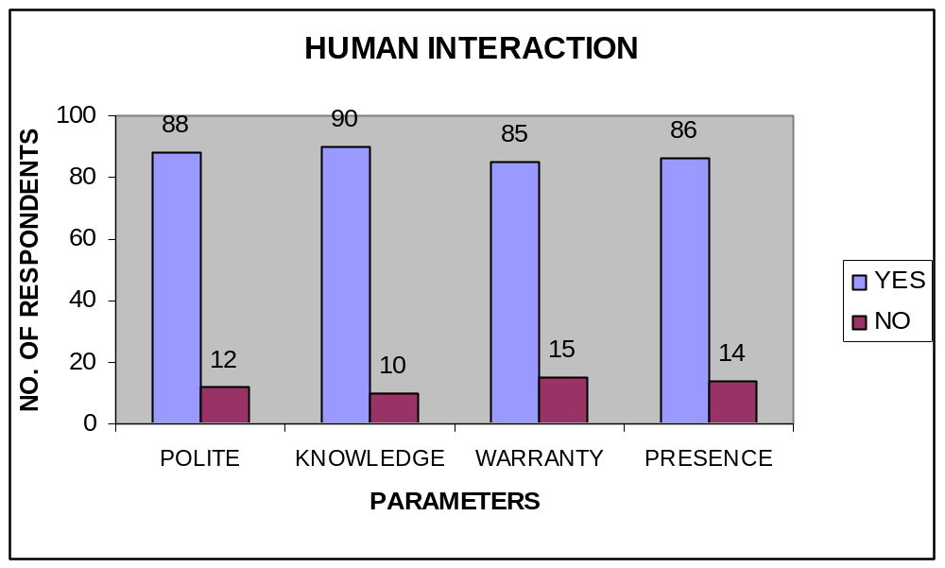
Interpretation
The personnel score a high 93 (approx.) in being courteous, polite, knowledgeable and communicating the warranty and schedule but there is a slight decrease in the attention provided at the time of delivery, which is area to concentrate. Nevertheless, the overall human interaction is above the acceptable levels.
Table-2
Product Information
SNO | OPINION | AVAILABILITY | KNOWLEDGE | TEST DRIVE
1 | YES | 88 | 86 | 88
2 | NO | 12 | 14 | 12
3 | TOTAL | 100 | 100 | 100
Inferences
The graph shows that the brochures, leaflets and price list are readily available. Approx. 85customers agree that the sales consultant was knowledgeable and was adept in handling the queries of the customers. And almost every customer was offered a test drive (96%).
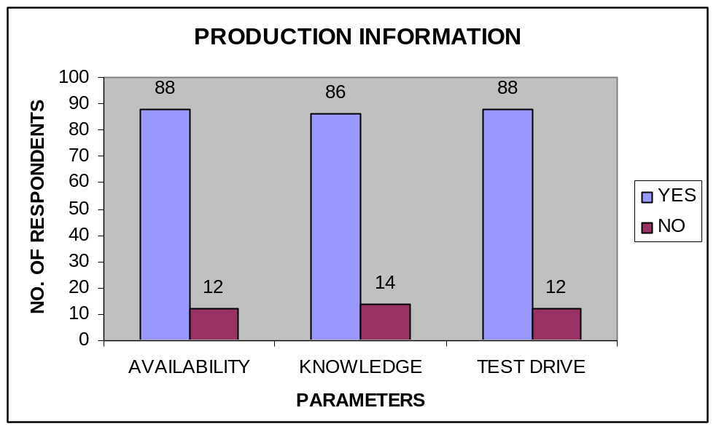
Interpretation: The showroom scores high in providing the relevant product information and is leaving no stone unturned to provide the specific information needs of the customers. This also reflects that the customer care personnel are well- equipped with the product information. At most care has been taken to ensure that the customers are provided with the product information.

Table-3
Time & Promptness

SNO | OPINION | FAST PROCESSING AT ORDER | DELIVERY AT PROMISED | FAST PROCESSING AT DELIVERY
1 | YES | 90 | 88 | 92
2 | NO | 10 | 12 | 08
3 | TOTAL | 100 | 100 | 100

Inferences
84 customers have responded positively about the work being carried out quickly. 25 people among customers are unhappy about the promptness in the delivery of the vehicle. Approximately 75 customers feel that the processing was fast.

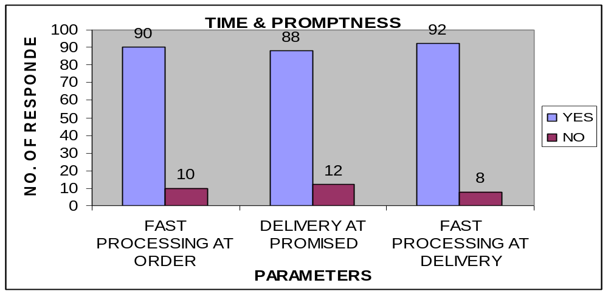

Interpretation
This is the area where the customer satisfaction level has gone down to 75, this area is to be handled well by the customer care as the other arrears are scoring well above 80. It is also to be noticed that the customer is anxious to get the delivery of the car as soon as possible, and the sales personnel have to take additional care to ensure that the customers is communicated the unavoidable delays well in advance.
Table-4
Consistency
Consistency in processing
SNO | OPINIONS | ORDER PROCESS | DELIVERY
1 | YES | 86 | 82
2 | NO | 14 | 18
3 | TOTAL | 100 | 100
Inferences
Consistency in processing:
The customers have responded positively, about 80 people (avg.) of them observing that the processing has maintained a consistent level.
CONSISTENCY IN PROCESSING
86
82
14
18
0
10
20
30
40
50
60
70
80
90
100
ORDER PROCESSING
DELIVERY
PARAMETERS
NO. OF RESPONDENTS
YES
NO
Interpretation
The showroom maintains a consistency level of 85% (avg. of processing consistency and consistency in human interaction), which is acceptable.
Table-5
Consistency in Human Interaction
SNO | OPINION | ALTERNATIVES | ALTERNATIVES
1 | YES | 90 | 88
2 | NO | 10 | 12
3 | TOTAL | 100 | 100
Consistency in Human interaction
The interaction with the customers has fallen from 93 prior to the sale to 86 after the sale is done.
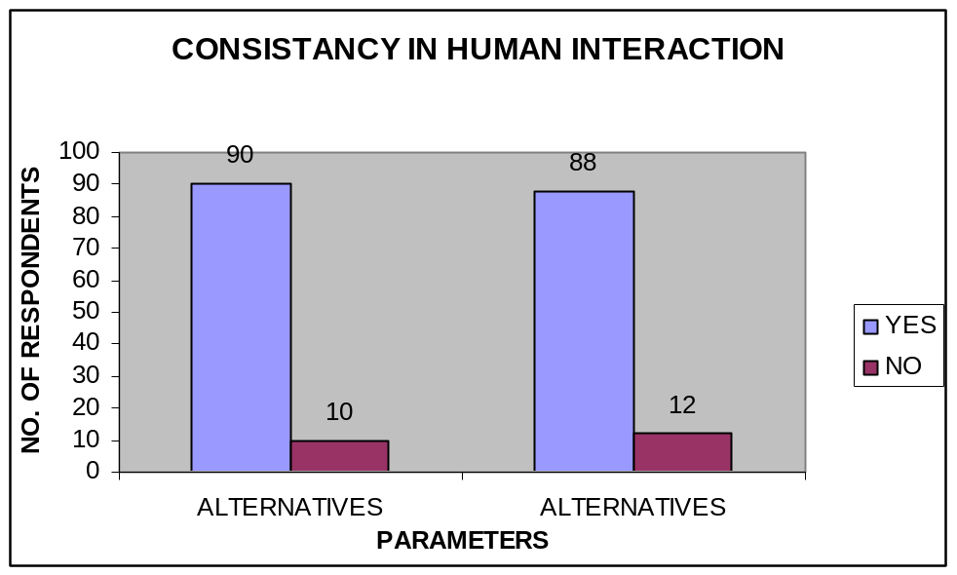
Interpretation
The showroom maintains a consistency level of 85 (avg. of processing consistency and consistency in human interaction), which is acceptable.

Table-6
Convenience
SNO | OPINION | MECHANIC | FUEL | TEST | AVAILABILITY | CONVENIENCE
1 | YES | 82 | 90 | 88 | 86 | 84
2 | NO | 18 | 10 | 12 | 14 | 16
3 | TOTAL | 100 | 100 | 100 | 100 | 100

Inferences
The showroom scores a very high percentage in providing convenience to the customers.
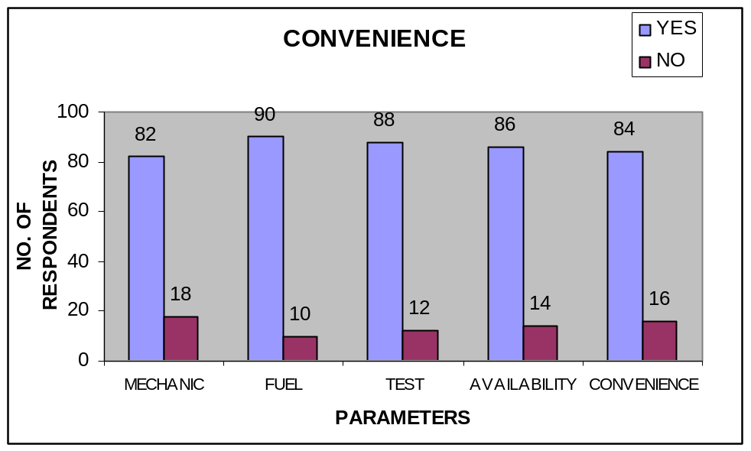

Interpretation
Though there are 20 of people who have not utilized the finance option provided by the showroom, the point to be taken is that 80 of the customers have utilized the options provided by the showroom.

CALCULATION OF SALES SATISFACTION INDEX

Sales satisfaction index is the index of overall satisfaction of Lakshmi customers as a whole. The overall satisfaction is the average of the scores of the key variables, which in turn is the cumulative of the positive responses of the customers, converted to a scale of ten. The responses of the customers have also been recorded over repeat purchases, referrals and their satisfaction to cross check with the calculated result

Sl.No | Key Deliverables | Score | Score on scale of Ten
1 | Human Interaction | 210/225 | 9
2 | Product Information | 215/225 | 9
3 | Time & Promptness | 175/225 | 7
4 | Consistency | 254/300 | 8
5 | Convenience | 413/450 | 9
 | Cumulative Score |  | 42

Sales Satisfaction Index

Overall Satisfaction = Average (Cumulative Score)
= 42/5
= 8.4

Sales Satisfaction Index = 8.4 on scale of ten

CHAPTER-5
DATA ANALYSIS

- Age group:

Sl.No | Age Group | No of people
A | 20 to 30 | 9
B | 30 to 40 | 25
C | 40 to 50 | 25
D | Above 50 | 22

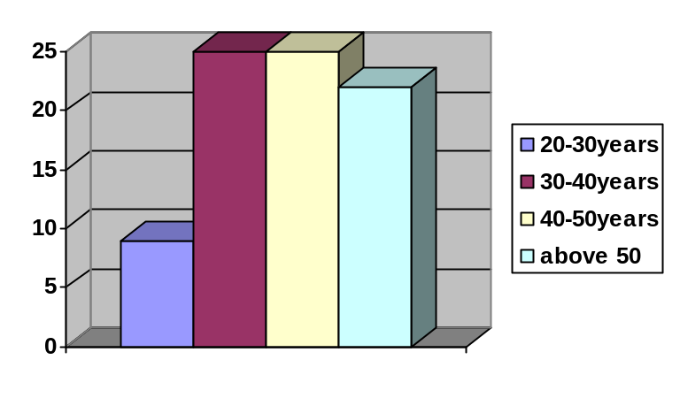

INTERPRETAION:

From the above table shows that the respondents of the age group of years above 50 i.e. 22, the next group is 40-50 years i.e.25, the remaining age groups are 30-40 and 20-30 years having 25 and 9 respectively.

- Occupation

Sl.No | occupation | No of people
A | Employee | 35
B | Business | 20
C | NRI | 15
D | Others | 8

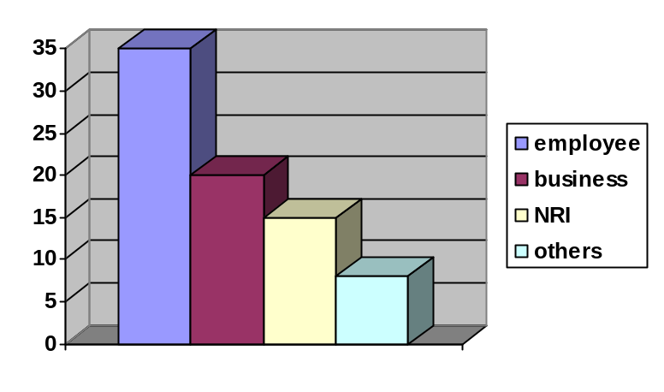

INTERPRETAION:

From the above table shows that the respondents of the occupation are mostly employees numbered 35, business people numbering 20 , NRI’s 15 and others 8 people.

- Which model of hyundai car do you own?

Sl.No | Brand | No of people
A | I10 | 35
B | Verna | 18
C | Accent | 10
D | Santro | 12

I10
A
,
35
verna
B
,
18
Accent
C
,
10
santro
D
,
12

Interpretation :-

The following graph shows the number of cars in the total of 75 persons i10 is owned by 35 people, and Verna owned by 18 and Accent owned by 10 people and Santro by 12 people.

- Which feature is the best one in Hyundai car ?

Sl.No | feature | NO of people
A | Mileage | 14
B | Price | 4
C | Brand | 16
D | Style | 18
E | Mileage & brand | 13
F | Mileage & style | 8

14
4
16
18
13
8
0
2
4
6
8
10
12
14
16
18
20
Mileage
Price
Brand
Style
Mileage
& Brand
Mileage
& Style
A
B
C
D
E
F
Series1

Interpretation:-

The following graph shows the number of what features you consider while you purchase in the total persons Mileage by 14, and Price by 4 and Brand by 16, Style by 18, Mileage and Brand by 13., and Mileage and Style by 8.

- how do you feel when you drive Hyundai car?

Sl.No | RANK | No of people
A | Good | 25
B | Better | 20
C | Best | 40
D | Poor | 5

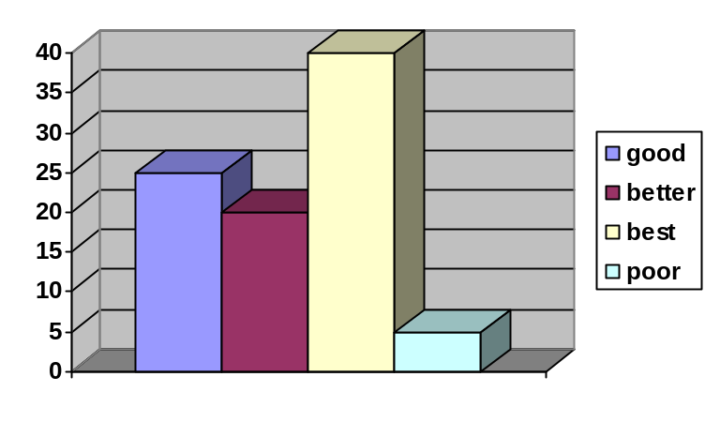

INTERPRETAION:

From the above table shows that the respondents of the experience of people while driving Hyundai cars is good i.e. 25, the next group is better i.e.20, the remaining people who feel best is 40 and others who feel poor experience are 5 respectively.

- Are you satisfied with your vehicle’s mileage?

Sl.No | Vehicle’s mileage | No of percentage
A | Yes | 61
B | No | 14

Yes
A, 61
No
B, 14
A Yes
B No

Interpretation :-

The following graph shows the number of people who satisfied with mileage of the vehicle in the total respondents response given by persons Yes by 61 and No by 14.

- Will you recommend Hyundai product to anybody?

Sl.No | Recommendation | No of percentage
A | Yes | 45
B | No | 30

Yes
A, 45
No
B, 30

Interpretation :-

The following graph shows the number of people who recommend Hyundai cars in the total persons yes by 45 and No by 30.

- What do you think about hyundai’s customer service?

Sl.No | RANK | No of people
A | Excellent | 40
B | Good | 20
C | Better | 30
D | Poor | 5

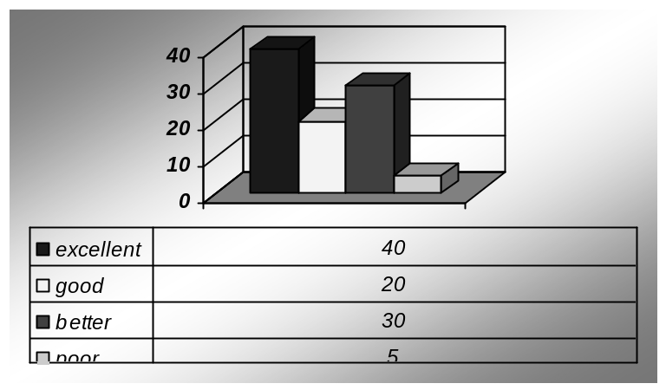

INTERPRETAION:

From the above table shows that the respondents of the people about Hyundai’s customer service is excellent i.e. 40, the next group is good i.e.20, the remaining people who feel better is 30 and others who feel poor experience are 5 respectively.

- How do you feel about company’s response towards customers?

Sl.No | Source | No of percentage
A | Excellent | 38
B | Good | 17
C | Better | 10
D | Poor | 7

17
38
10
7
0
5
10
15
20
25
30
35
40
Good
Excellent
Better
Poor
A
B
C
D
Series1

Interpretation :-

The following graph shows the number of response of customers towards the products from the total number of 100 people good are good 17, Excellent 38, better 10 and poor are 7.

10.Did you receive the product on delivery time?

Sl.No | Delivery time | No of percentage
A | Yes | 55
B | No | 20

Yes
A, 55
No
B, 20
A Yes
B No

Interpretation :-

the following graph shows the number of customers who receive the product on delivery time is yes by 55 customers and no by 20 customers.

- Are you satisfied with company’s after sales service ?

Sl.No | After sales service | No of percentage
A | Satisfied | 75
B | Not satisfied | 5

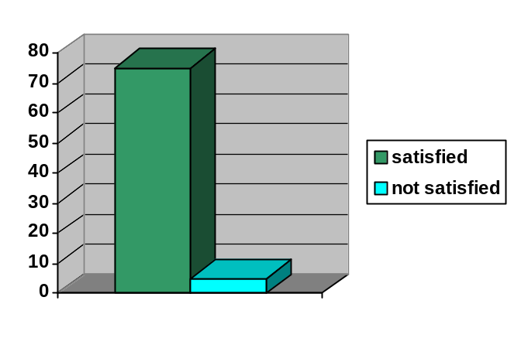

Interpretation:
The number of customers who satisfy/not satisfied with the after sales service of the company from a number of 100 customers are satisfied 75 and not satisfied 5.

12. how do you feel the experience at show room?

Sl.No | Best Brand Ambassadors | No of percentage
A | Satisfied | 55
B | Not satisfied | 29


Not satisfied
Satisfied
A
B
Series1

Interpretation :-

The following graph shows the consumer’s experience at show room the number of customers who satisfy is 55 and who does not satisfy is 29

- Were you offered test drive?
Sl.No | Test drive | No of people
A | Yes | 80
B | No | 7

Yes
A, 80
No
B, 7
A Yes
B No

Interpretation :-

The following graph shows the number of customers who were offered test drive for the product is yes by 80 customers and no by 7 customers.

14) have you satisfied with the usage of Hyundai cars?

Sl.no | Customer response | percentage
A | Fully satisfied | 71
B | Just satisfied | 15
C | Not satisfied | 4

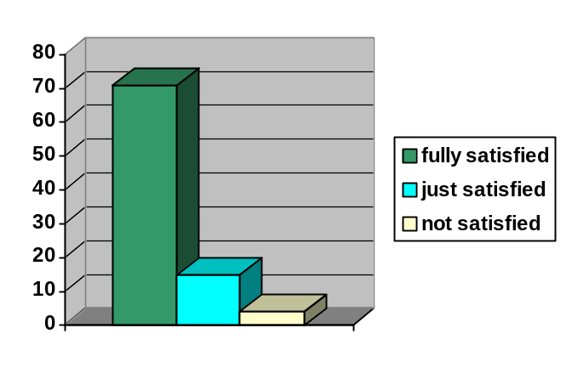

INTERPRETAION:

The following table shows that the respondents who satisfied with dealer’s performance is better71,good 15 and Poor is 4.

CHAPTER-6
FINDINGS & SUGGESTIONS

CONCLUSIONS AND FINDINGS

- Lakshmi Hyundai enjoys a high patronage from its customers.

- Most of the customers had a good experience of shopping at Lakshmi Hyundai.

- The satisfaction levels can also measured with the level of recommendations to friends and associates; It is evident that more than 80% customers are satisfied with the service offered at Lakshmi Hyundai.

- The probability that the customers would repeat that purchase at the same showroom is high, which is a good sign.

- The sale satisfaction index of Lakshmi Hyundai showroom is 8.4 on scale of ten (refer page 32), which is exceptionally good, the showroom should persist on high levels of commitment to maintain the good image it has created. The industry SSI (2003) is 104 out of 126 according to J D Power Asia pacific. And Hyundai scores 105 out of 125.

- In the interview it was found that the customers are happy about the training
programs under taken by the showroom, which train the customers to negotiate minor breakdowns comfortably.

- It has been observed that 25% of customers have reported a slack in the delivery
process.

This is the only area of concern that has emerged form the city.

SUGGESTIONS

The overall sales satisfaction index from the study reveals that the company is performing very well and customers buying are much satisfied with the service given to them.

The only couple problem noticed are:

    - Some of the customers have complained about the slack in the delivery process and timings. Therefore, this is the area which I recommend to the showroom to focus a little bit more. It needs to improve its delivery process and time. Need to become little quick and fast.

Some of the customers have also complained about the after
purchase services provided by the showroom. Even though the
complaints are minor, the showroom needs to resolve the
customer after purchase service issues in order to achieve
customer satisfaction.

ANNEXURE

CUSTOMER SATISFACTION INDEX
Details:
Vehicle No: _______________________________________________________
Model: ___________________________________________________________
Customer Name: __________________________________________________
Telephone No: ______________________Mobile:________________________
Date: __________________Customer signature: ________________________

1. Age group
a) 20-30 b) 30-40 c) 40-50 d) Above 50

2. Occupation?
a) Employee b) business c) NRI d) others

3. Which model of hyundai car do you own?
a) Santro b) Verna c) Accent d) i10 e) i20

4.which feature is the best one in Hyundai car?
a) price b) style c) mileage d) quality e) mileage&quality
e) mileage & style

- How do you feel when you drive hyundai car?
- Good B) better c) best d) Poor
6. Are you satisfied with your vehicle mileage?
a) Yes b) No

7. will you recommend hyundai product to anybody?
a) Yes b) No

- what do you think about hyundai’s customer service?
- Excellent b) Good c) Better d) Poor

9. How do you feel about company’s response towards customers?
a) Excellent b) Good c) Better d) Poor

10. did you receive the product on delivery time?
a) Yes b) No

11. are you satisfied company’s after sales service?
a) Satisfied b) not satisfied

12. How do you feel the experience at the showroom?
a) Satisfied b) not satisfied

13. were you offered test drive?
a) Yes b) No

14. Are you satisfy with their usage of the car?
a) fully satisfied b) just satisfied c) not satisfied

15. Please give your comments/suggestions to enable us to improve satisfaction of customers at this Hyundai authorized showroom.

__________________________________________________________________

__________________________________________________________________

Attachment – 2

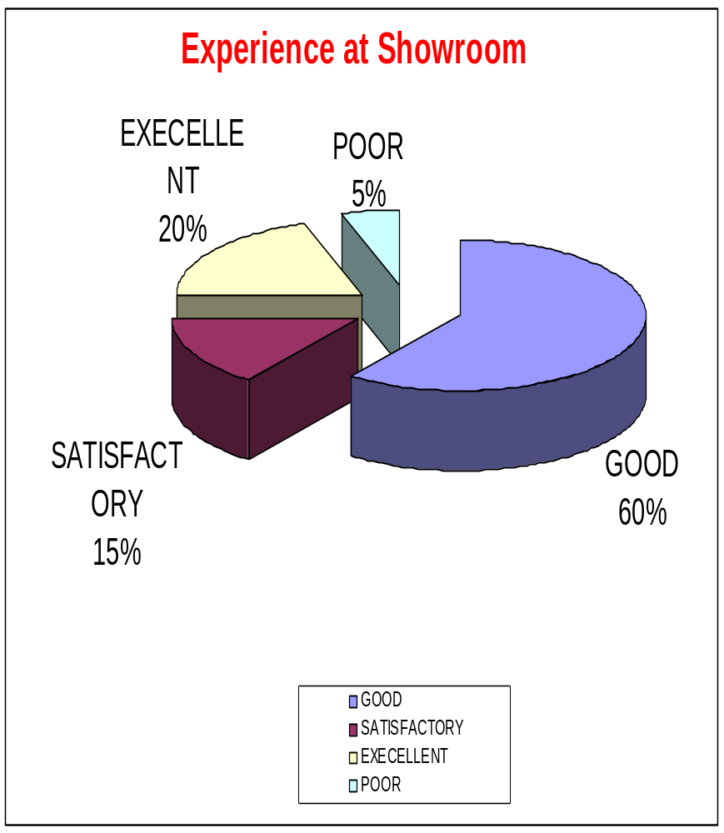

Attachment – 3

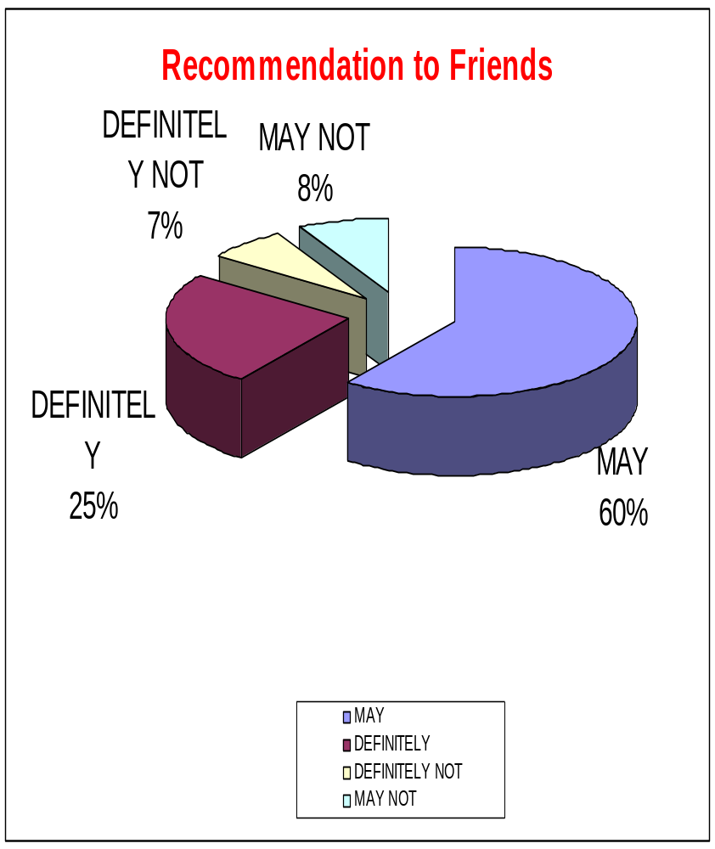

BIBLIOGRAPHY

BIBLIOGRAPHY

Books:
Principles of marketing: KOTLER ARMSTRONG.
Marketing Management: PHILIP KOTLER.
(Analysis, Planning Implementation and Control)
Services Marketing : TATA Mc GRAW HILL.
Marketing Research : G.C.BERI.
Research Methodology: KOTHARI. C.R.

Websites:
http://www.jdpower.co.jp
www.bus.umich.edu
http://www.asq.org

Hyundai Car models

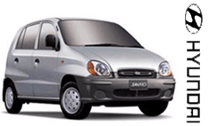 Santro

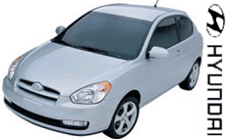 Accent

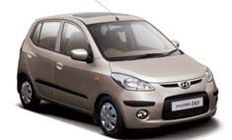 I10

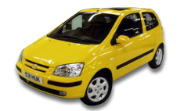GETZ

 VERNA

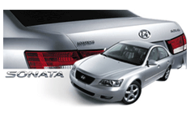 SONATA

 TUCSON

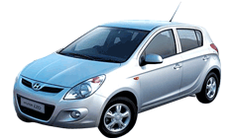 i20

 ELANTRA

